CO2 EMISSIONS PROJECT
FINAL REPORT

Project Team: #jul26_bds_int_co2
Serhat Gemici
Computer Engineer
Specialised in Soft Computing and Software Quality
Mentor: Yaniv Benichou
06.10.2026

INTRODUCTION

1. Context

Business integration
This project analyses European vehicle-registration and technical data to understand the relationship between vehicle characteristics and official WLTP CO₂ emissions. The project team does not work directly in the automotive sector; however, the subject is relevant to organizations involved in sustainability reporting, environmental monitoring, vehicle classification, regulatory compliance, and transport planning.
The intended outcome is a reusable data-analysis and machine-learning framework that can estimate CO₂ emissions from vehicle specifications before complete emissions information is available. Such a framework could support preliminary environmental assessments, comparisons between vehicle categories, and data-driven decision-making during product or fleet analysis. It should be understood as an analytical support tool rather than a replacement for official homologation tests.

Technical perspective
From a technical perspective, the project involves working with large, heterogeneous and imperfect real-world datasets. The main activities include data acquisition, schema comparison, data cleaning, missing-value analysis, data validation, exploratory data analysis, feature engineering, categorical encoding, leakage prevention, outlier analysis, standardization, and preparation for machine-learning modelling.
Particular attention was given to vehicle-family identifiers, type-approval codes, manufacturer names, fuel categories, and variables with high cardinality. Several identifier and regulatory fields were excluded because they could cause overfitting or target leakage. The workflow was implemented using Python-based data-science tools, including pandas, NumPy, Matplotlib, Seaborn, scikit-learn, joblib, and category-encoding techniques.

Economic perspective
A reliable emission-estimation framework could reduce the time and manual effort required to analyze large vehicle datasets. It could also help organisations identify emission patterns at an early stage, compare manufacturers or fuel technologies, and prioritize more detailed investigations.
The project does not claim to replace laboratory testing or official regulatory procedures. Instead, its economic value lies in enabling scalable preliminary analysis using existing data. By automating repetitive processing and providing reproducible analytical steps, the approach could support future reporting, monitoring, benchmarking, or decision-support applications.

Scientific perspective
Scientifically, the project combines statistical analysis, machine learning, environmental data analysis, software engineering, and physical interpretation of vehicle emissions. It investigates how mass, engine displacement, engine power, fuel type, fuel mode, vehicle category, and manufacturer-related variables are associated with WLTP CO₂ emissions.
The interdisciplinary nature of the team is important. Dr. Ana Valencia Garcia contributes a physics background through a PhD in Theoretical Physics, while Serhat Gemici contributes expertise in computer engineering and software quality. The collaboration aims to produce a transparent, reproducible, and scientifically defensible approach to emission prediction.

2. Objectives
The principal objective is to examine the relationship between the technical specifications of newly registered vehicles in Europe and their official WLTP CO₂ emissions, and to prepare a model capable of estimating emissions from relevant vehicle characteristics.
The project has the following specific objectives:
- Analyze European vehicle-registration data and identify its structure, quality issues, limitations, and potential biases.
- Identify the technical and categorical variables most relevant to CO₂ emissions.
- Compare the French ADEME dataset with the European Environment Agency dataset.
- Clean and standardize the data so that it can be used reliably in machine-learning workflows.
- Detect missing values, inconsistent codes, duplicate records, extreme values, and structural anomalies.
- Engineer usable features from categorical and numerical variables.
- Prevent target leakage caused by variables that directly encode or reproduce the target value.
- Prepare a reproducible training and evaluation pipeline for future modelling.
- Investigate whether vehicle emissions can be estimated accurately from specifications available before official testing.

Team expertise
Team member | Background and relevant expertise
Ana Valencia Garcia | PhD in Theoretical Physics. Brings expertise in scientific reasoning, physical interpretation, quantitative analysis, and the evaluation of environmental relationships.
Serhat Gemici | BSc in Computer Engineering and MSc in Engineering Management. Brings experience in software quality, data processing, Python, test automation, and reproducible technical implementation.
The team’s combined expertise covers both the physical interpretation of emissions and the computational implementation required to process large datasets and prepare predictive models.

Business-expert interaction
The project was developed primarily from publicly available regulatory and governmental data sources. No direct automotive-industry expert interaction is documented in the presentation. Consequently, the underlying problem definition was refined through the official data documentation, European emissions regulations, variable descriptions, exploratory analysis, and discussions with the project mentor.
If the project is extended, interviews with automotive homologation specialists, fleet managers, regulatory consultants, or emissions engineers would be valuable. Such interactions could help validate the interpretation of fields such as VFN, RLFI, type-approval identifiers, test mass, fuel mode, and eco-innovation codes.

Similar projects and surrounding work
The project uses concepts commonly found in vehicle-emission analysis, regulatory reporting, fleet benchmarking, and environmental machine learning. However, no specific comparable internal company project is identified in the presentation. The current work contributes by combining two complementary perspectives:
- A historical French dataset from ADEME, useful for understanding earlier vehicle-data structures and data-quality challenges.
- A large European Environment Agency dataset containing 2024 new-registration data, used as the primary analytical basis.
The comparison between these sources helps distinguish historical French catalogue information from more recent European registration data and clarifies which variables can be compared across datasets.

DATA EXPLORATION

& FEATURE ENGINEERING

1. Understanding and Manipulation of Data

Data framework
The project uses two principal data sources:
- European Environment Agency data
- Data concerning CO₂ emissions from newly registered passenger vehicles in Europe.
- Submitted by EU member states under Regulation (EU) 2019/631.
- The main analytical dataset is the 2024 release.
- The presentation reports approximately 10.78 million rows and 29 country codes before filtering.
- The dataset includes technical vehicle specifications, fuel information, manufacturer information, registration information, and official WLTP emissions.
- French ADEME data
- French governmental data concerning vehicles marketed in France.
- Covers historical years from 2001 to 2015.
- The schema changes considerably over time, ranging from approximately 12 to 30 columns.
- The 2015 dataset contains approximately 20,880 observations and detailed technical, emissions, pollutant, and administrative variables.
The datasets are publicly available through governmental and European data portals. The relevant sources identified in the presentation are the European Environment Agency and data.gouv.fr. The data is therefore not proprietary to the project team, although its collection, publication, and regulatory ownership remain with the relevant public institutions.

Dataset volume
The EEA 2024 dataset is very large, with more than 10 million records in its original form. The presentation later describes a cleaned French 2024 dataset containing approximately 119,380 rows and 18 columns for the modelling preparation stage.
The ADEME data is considerably smaller but historically more heterogeneous. The 2015 ADEME dataset contains approximately 20,880 rows, while the French EEA comparison dataset contains approximately 28,051 records.
The large EEA dataset creates practical challenges involving memory use, processing time, categorical cardinality, duplicate handling, and efficient exploratory analysis.
After comparative analysis between EEA and ADEME datasets, for reasons detailed in the data limitations section we have decided to drop the ADEME dataset and continue our study using EEA dataset. Furthermore, considering the file size of the EEA dataset, we have decided to continue our study by filtering the EEA dataset by France and limit our study to use 2024 final dataset for training and validation and 2025 provisional dataset for testing.

2. Relevance of the Data

Target variable
The principal target variable is:
- Ewltp (g/km): official WLTP CO₂ emissions.
For the ADEME dataset, the corresponding target is:
- co2_mixte: combined CO₂ emissions in grams per kilometre.
The target represents an official laboratory or homologation value. It should not be interpreted as a direct measurement of real-world emissions under all driving conditions.

Relevant variables
The most relevant candidate predictors include:
For the EU dataset, important variables include:  - m: vehicle mass in kilograms.  - Mt: WLTP test mass.  - ec: engine displacement in cubic centimetres.  - ep: maximum engine power in kilowatts.  - Ft: fuel type.  - Fm: fuel mode.  - Electric range: electric driving range.  - z: electric energy consumption in Wh/km.  - Ct: type-approval vehicle category.  - Mk: vehicle make or brand.  - IT: eco-innovation technology indicators. | For the ADEME dataset, important variables include:  - Vehicle mass.  - Maximum engine power.  - Combined fuel consumption.  - Fuel type.  - Hybrid status.  - Transmission type.  - Engine and pollutant measurements.  - Manufacturer and model information.

Important dataset characteristics
Several characteristics of the data are particularly important:
- The EEA dataset is strongly imbalanced by country. Germany, France, Italy, and Spain account for approximately two-thirds of the records.
- The 2024 dataset mainly represents passenger vehicles. Approximately 98.79% of vehicle categories are reported as M1, while M1G represents approximately 1.20%.
- Fuel categories are unevenly represented. Petrol, diesel, all-electric, and petrol/electric vehicles make up most records.
- Electric variables are highly zero-inflated because they are generally not applicable to conventional internal-combustion vehicles.
- Manufacturer and model fields have high cardinality and require careful treatment.
- Some regulatory identifiers can indirectly encode test conditions or emissions information, making them unsuitable as direct model inputs.
- The EU EEA dataset is huge. Only for the year 2024 alone is 2.53 GB, containing millions of entries. In order to be able to carry our study, we will be working on a subset of 2024 data filtered for Country=France.

Data limitations
The following limitations were identified:
- The data represents newly registered vehicles, not the complete European vehicle fleet.
- Registrations are not equivalent to sales volume because the r field is constant at 1.
- Countries are unevenly represented.
- WLTP values are laboratory-based and do not capture traffic, weather, driving behaviour, maintenance, or road conditions.
- Electric-vehicle tailpipe CO₂ does not represent total life-cycle emissions.
- Country of registration does not necessarily indicate country of manufacture or actual country of use.
- Manufacturer and model names are not fully standardised.
- Some variables are systematically missing depending on powertrain type.
- The EEA dataset does not provide all historical fields available in the ADEME source.
- ADEME is limited to historical data and was discontinued after 2015.
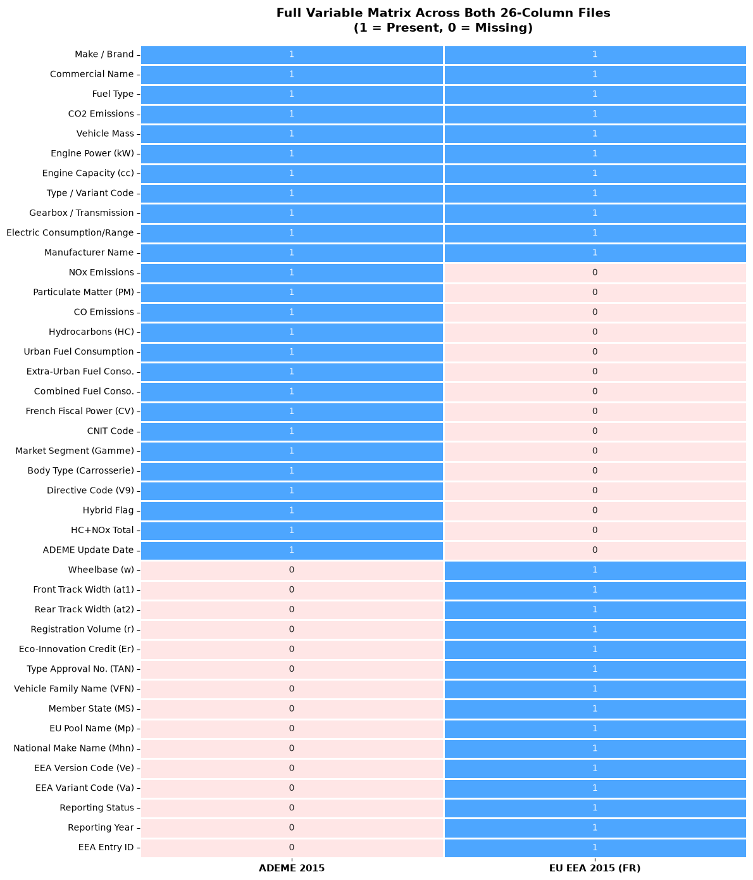
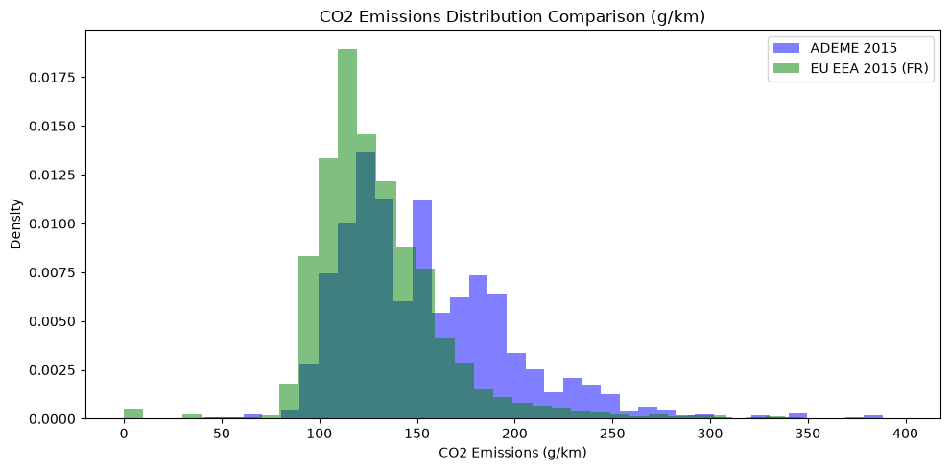

3. Data Pre-processing and Feature Engineering

Initial cleaning
The preprocessing workflow included:
- Loading the datasets with pandas.
- Inspecting schemas and data types.
- Comparing variable availability between years and datasets.
- Removing duplicate records.
- Investigating inconsistent naming conventions.
- Identifying columns with complete missingness.
- Detecting constant and zero-variance columns.
- Inspecting invalid or inconsistent regulatory identifiers.
- Analysing missingness patterns and potential missing-not-at-random behaviour.
In the EEA 2024 data, the following fields were reported as 100% missing and were removed:
- MMS
- Enedc
- Ernedc
- De
- Vf
- ech
Several fields were constant:
- Country
- Status
- year
- r
- Cr
These variables were marked to be removed later because they provided no useful variation for the selected modeling task.

Vehicle identifiers and regulatory codes
The following fields were carefully examined:
- VFN
- Tan
- T
- Va
- Ve
- RLFI
Although these codes contain useful regulatory information, they have very high cardinality and may cause the model to memorize vehicle families or laboratory configurations. Such memorisation would reduce generalization to new vehicles.
The VFN field was also checked for structural validity. Most records followed an IP-based format, but a small number of records contained irregular values such as missing components, alternative prefixes, or incomplete codes. These records were isolated for quality review rather than automatically treated as valid.
The decision was made to exclude high-cardinality regulatory identifiers from the principal model and focus on physical and meaningful categorical features.

Manufacturer and model processing
The manufacturer feature was target-encoded to preserve information about average emissions by manufacturer while avoiding a very large one-hot-encoded matrix. This operation must be performed carefully inside the training pipeline to avoid target leakage between training and test data.
Model names were transformed using frequency encoding rather than one-hot encoding. This retained information about model frequency without creating thousands of sparse columns.

Fuel-related processing
Fuel type and fuel mode were converted into categorical features using one-hot encoding. This approach avoids incorrectly assigning an ordinal relationship to categories.
The principal retained fuel categories were:
- Petrol.
- Petrol/electric.
- Petrol/diesel
- Diesel.
Low-frequency categories such as diesel/electric, E85, and LPG were removed in the modeling preparation stage because their small representation could produce unstable estimates.
The ng or unknown-fuel category was also removed because it represented a very small proportion of the data and lacked corresponding fuel-consumption information.

Missing-value treatment
Missingness was not treated uniformly. The analysis recognized that some missing values are structural rather than accidental:
- Electric range and electric consumption are naturally absent for many combustion vehicles.
- Electric power fields are primarily relevant to electric or hybrid vehicles.
- Pollutant fields may be absent because testing requirements vary according to powertrain type.
Missing electric range and electric-consumption values were set to zero where zero represented “not applicable for a non-electric vehicle.” This assumption should be documented clearly because zero and unknown are not always equivalent.

Target leakage prevention
Two variables were marked suspicious, because they provided information too directly related to the target:
- Fuel consumption: It has a near-deterministic physical relationship with CO₂ emissions and would make the prediction problem artificially easy.
- Erwltp: It represents an adjustment or regulatory value closely connected to WLTP emissions.
Removing these variables forces the model to learn from more fundamental vehicle characteristics such as mass, engine displacement, power, fuel type, and manufacturer.

Train-test split
The data was initially divided using an 80/20 train-test split with random_state=42. The split was performed before scaling and outlier filtering to ensure that the test data remained unseen during model preparation.
For a stronger evaluation in the modeling phase, it was noted that it would also be useful to consider:
- Grouped splitting by vehicle model or manufacturer.
- Time-based splitting if multiple registration years become available.
- Evaluation on manufacturers or models not present in the training set.

Standardization
Numerical variables were standardized using StandardScaler. The scaler was fitted only on the training data and then applied to the test data:
X_train_scaled = scaler.fit_transform(X_train)
X_test_scaled = scaler.transform(X_test)
Standardization is useful for models that are sensitive to feature scale, including linear regression, support-vector machines, k-nearest neighbours, and neural networks. Tree-based models generally require less scale preparation, but using a consistent preprocessing pipeline remains good practice when comparing multiple algorithms.

Dimension reduction
No mandatory dimension-reduction technique was required for the initial feature set because high-cardinality identifiers were removed or encoded before modeling. If the final encoded feature space becomes large, dimension reduction could be considered for exploratory purposes or for models that are sensitive to sparse, high-dimensional input.
Potential methods include:
- Principal Component Analysis for numerical variables.
- Truncated SVD for sparse encoded matrices.
- Feature selection based on mutual information or model importance.
Any dimension-reduction step should be fitted only on the training data.

4. Visualizations and Statistical Analysis

Relationships between explanatory variables
The exploratory analysis identified several important relationships:
- Vehicle mass is positively associated with emissions.
- Engine power and engine displacement are positively associated with emissions.
- Mass and WLTP test mass are strongly related.
- Fuel type produces clear separation between low- and high-emission groups.
- Electric range and electric consumption are concentrated among electrified vehicles.
- Manufacturer and model distributions are highly concentrated.
- Some regulatory codes are strongly associated with specific vehicle families and manufacturers.
The strong relationship between m and Mt creates a multicollinearity concern. Although Mt is closely linked to laboratory testing, m is more appropriate for future prediction because curb mass may be available before the vehicle has completed official testing. Consequently, m was marked to be retained and Mt was marked to be excluded.
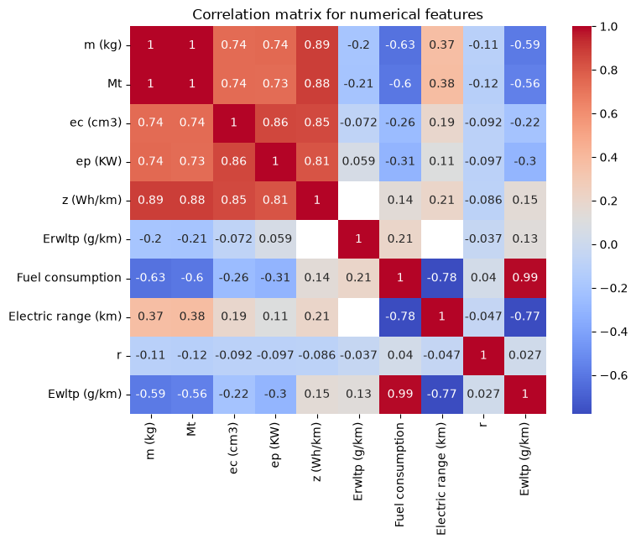
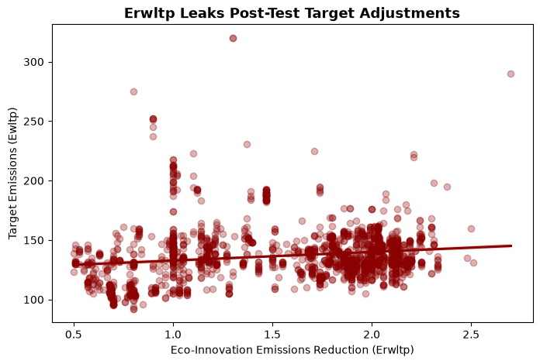

Target distribution
The EEA target, Ewltp, has:
- Mean of approximately 106.79 g/km.
- Median of approximately 123 g/km.
- Values ranging from 0 to approximately 543 g/km.
- A distribution containing a pronounced low-emission or zero-emission group and a higher-emission combustion group.
The zero values are consistent with the treatment of electric and hydrogen vehicles in the dataset. This creates a bimodal or zero-inflated target distribution rather than a simple symmetric distribution.
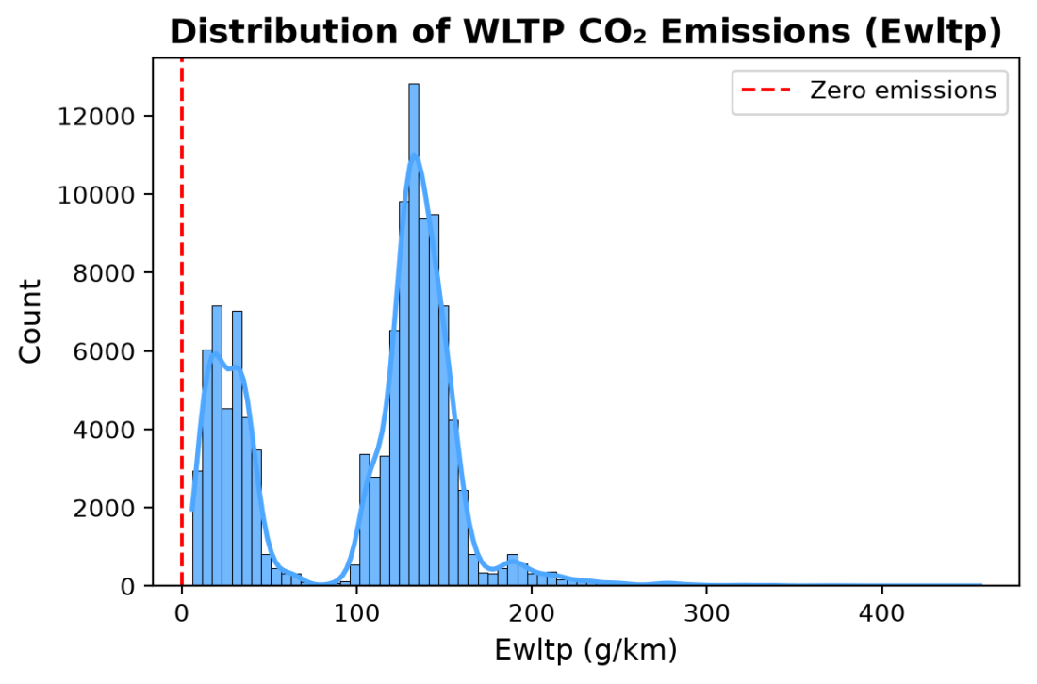

Fuel-type relationships
The presentation identifies substantial differences between fuel categories:
- All-electric and hydrogen vehicles have an average tailpipe value close to 0 g/km.
- Diesel/electric plug-in hybrids have a reported average of approximately 14.78 g/km.
- Petrol/electric vehicles have a reported average of approximately 27.51 g/km.
- Petrol vehicles have a reported average of approximately 130.74 g/km.
- Diesel vehicles have a reported average of approximately 149.83 g/km.
- Unknown fuel entries have a reported average of approximately 214 g/km, although they represent a very small part of the dataset.
These differences indicate that fuel type is likely to be one of the most influential categorical predictors.
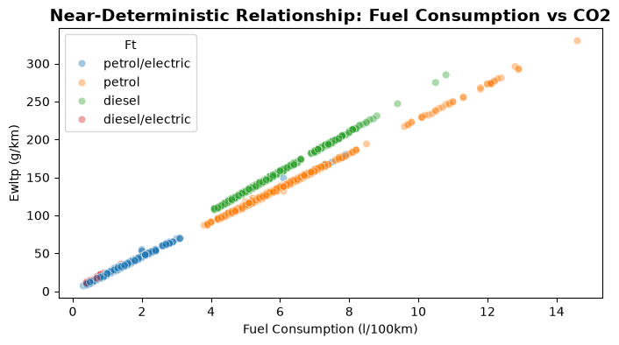
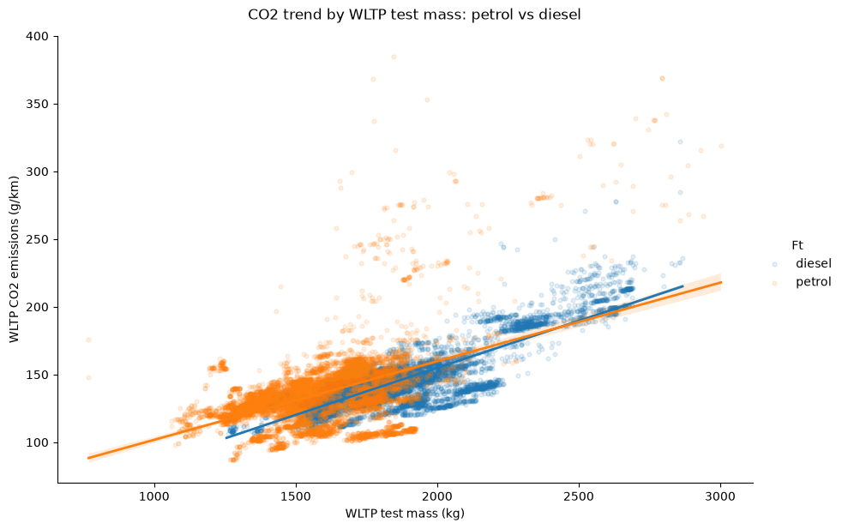

Numerical distributions and outliers
The numerical variables have different distribution shapes:
- ep is strongly right-skewed, with skewness of approximately 2.24.
- ec is right-skewed, with skewness of approximately 1.45.
- Electric range has a skewness of approximately 1.41.
- z has skewness of approximately 1.08.
- m has moderate right skewness, approximately 0.85.
- Ewltp is comparatively close to symmetric at approximately -0.34, although its zero-emission group creates a meaningful mixture structure.
- Fuel consumption is also comparatively well behaved after appropriate filtering.
For vehicle mass, the mean is approximately 1,558.77 kg, the median is approximately 1,483 kg, and the range is approximately 513–4,800 kg. An IQR-based rule identifies many statistical outliers, but only a small number of records fall outside more conservative physical boundaries. This distinction is important: a statistical outlier is not automatically an erroneous vehicle.
For engine power, the mean is approximately 116.18 kW, while the maximum is approximately 1,352 kW. Very low or extremely high values require domain-specific validation rather than automatic deletion.
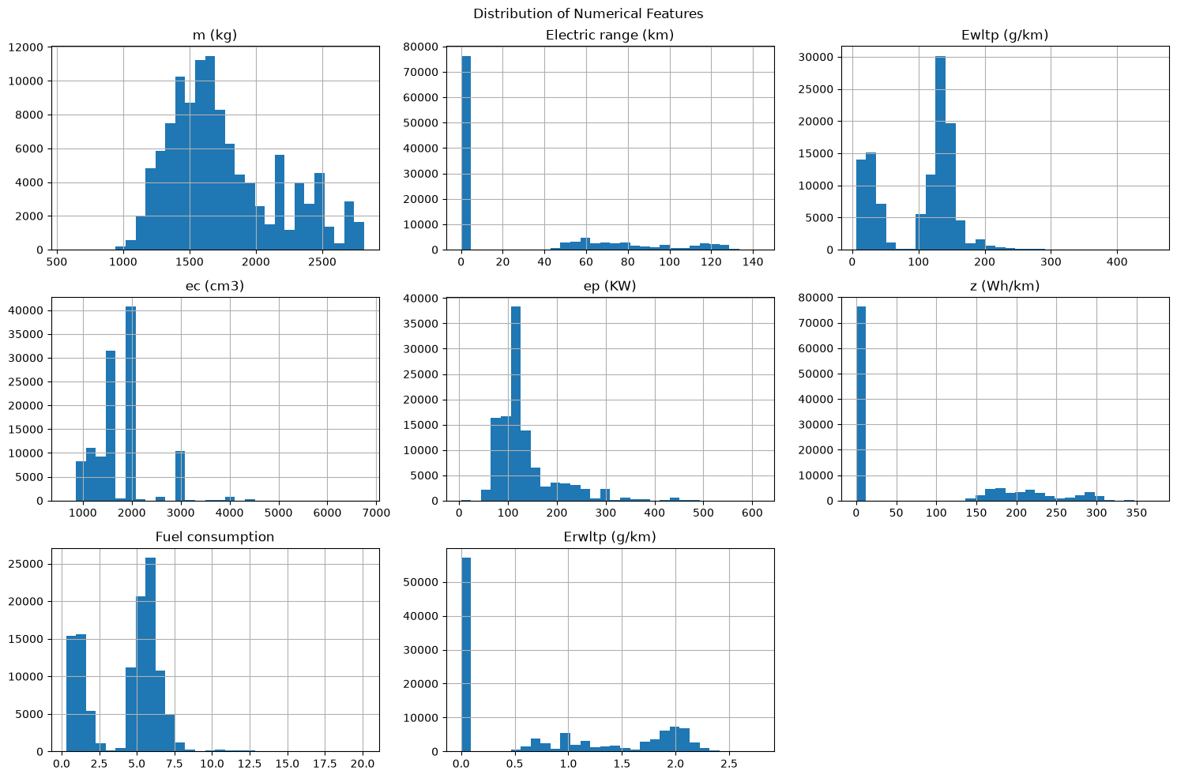

Statistical analysis
The project used or prepared the following statistical methods:
- Descriptive statistics, including count, mean, median, standard deviation, minimum, maximum, and quartiles.
- Missing-value percentage analysis.
- Frequency and cardinality analysis for categorical variables.
- Skewness calculations for numerical columns.
- IQR-based outlier detection.
- Grouped mean comparisons by fuel type and manufacturer.
- Correlation analysis between numerical predictors and emissions.
- Distribution plots and histograms.
- Scatter plots for relationships such as fuel consumption and emissions.
- Comparative analysis between ADEME and EEA datasets.
The relationship between fuel consumption and WLTP emissions was found to be almost deterministic. This statistical and visual evidence supported the decision to remove fuel consumption from the model as a target-leaking feature.
For the modeling phase, the statistical analysis should be complemented by:
- Pearson or Spearman correlation tests for numerical associations.
- Group comparison tests across fuel categories.
- Confidence intervals for grouped emission means.
- Residual analysis after model training.
- Cross-validation and error analysis by fuel type, manufacturer, and vehicle category.

6. Conclusions Made For The Modeling Phase
The exploratory and preprocessing work supports the following modeling decisions:
- Use physical vehicle characteristics as the principal predictors.
Mass, engine displacement, power, fuel type, fuel mode, electric range, and energy consumption contain meaningful information about emissions.
- Treat fuel type as a major predictor.
The target distribution differs substantially between combustion, hybrid, and electric powertrains.
- Avoid regulatory identifiers as direct model features.
VFN, Tan, RLFI, T, Va, and Ve can have high cardinality, weak portability, and a high risk of memorization or target leakage.
- Prefer curb mass over test mass for future prediction.
Curb mass is more likely to be available before official testing, while test mass is closely tied to the laboratory procedure.
- Exclude fuel consumption from the main predictive feature set.
Although it is highly predictive, it provides an almost direct physical proxy for the target and would undermine the intended prediction task.
- Handle electric vehicles carefully.
Zero-emission vehicles create a distinct subpopulation. Separate modelling by powertrain or a two-stage modeling strategy may be appropriate.
- Use a leakage-safe preprocessing pipeline.
Target encoding, standardization, imputation, and feature selection must be fitted only on training data.
- Evaluate generalization, not only random-split accuracy.
Because vehicle models and manufacturers can repeat across the dataset, a random split may produce optimistic results. Grouped or time-based validation should be considered.
- Report limitations alongside model performance.
Predictions will estimate official WLTP-type emissions from available technical specifications; they will not represent real-world driving emissions or life-cycle carbon impact.
- Preserve reproducibility.
The final project should retain the data-cleaning rules, feature definitions, validation decisions, preprocessing pipeline, model parameters, and evaluation results.
Overall, the project has established a suitable foundation for supervised machine-learning experiments. The data exploration shows that the prediction problem is technically feasible, but the modeling phase must be designed carefully to manage strong categorical effects, zero-inflated electric features, missing-not-at-random data, manufacturer concentration, and leakage from regulatory or post-test variables.

MODELING AND FINE TUNING

Executive Summary

This report presents the final leakage-aware modeling workflow for predicting official WLTP CO₂ emissions (g/km) for French vehicles. The 2024 data were used for development, group-aware validation, feature selection and hyperparameter tuning; the 2025 data were held out as a temporal test set. The modeling report consists of 2 parts, where part 1 represents execution performed on the complete dataset, part 2 represents the execution that was performed on segmented datasets based on fuel modes; namely Mono, PHEV (Plug-in hybrid electric vehicles) and Hybrid.

Executive conclusion part 1: An initial modeling test was performed with the initial random split dataset prepared during the data exploration and feature engineering phase, given the results were far away from optimal, the approach was dropped and study continued using a group based splitting and tested feature sets. The first trial modeling will not be included in this report, however the Jupyter notebook that contains this study (named 03_modeling.ipynb) can be found in our repository.
The project progressed from an overly optimistic first benchmark to a leakage-aware final workflow. The strongest conventional model was a tuned ExtraTreesRegressor. On the final workflow, it achieved validation RMSE 6.63 g/km and 2025 test RMSE 10.58 g/km, MAE 5.03 g/km and R² 0.9625. A neural network was also successful: its best reported test result was RMSE 8.67 g/km and MAE 6.67 g/km. The Lightning MLP had a lower reported RMSE but a higher MAE than the final ExtraTrees model; because the evaluation workflows may not be identical, the results should not be treated as a definitive head-to-head comparison. ExtraTrees remains the primary recommendation because it is the fully validated and interpreted model in the final temporal workflow.

Executive conclusion part 2: The workflow progressed from duplicate consolidation and leakage investigation to a tuned ExtraTreesRegressor. ExtraTrees was selected as the primary conventional model. The extension notebook then trained separate models for Mono-fuel (M), PHEV (P) and Hybrid (H) vehicles, allowing errors and feature importance to be analysed within powertrain regimes.

The segmented ExtraTrees evaluation on 2025 produced MAE 5.0343 g/km, RMSE 10.5761 g/km and R² 0.9625. Mono and Hybrid models performed substantially better than the PHEV model. The principal weakness was systematic under-prediction for unseen petrol/electric PHEV configurations.

MODELING PART I:

Analysis On Complete Dataset

1. Data Preparation and Experimental Design
The target is Ewltp (g/km), the official WLTP CO2-emission value. The 2024 French dataset was used for model development, and the 2025 French dataset was held out as a temporal final test. The final notebook reports 15,957 aggregated 2024 records and 14,735 aggregated 2025 records; the final group split contained 12,801 training rows and 3,156 validation rows.
A central improvement was replacing a simple random-style benchmark with a group-aware split. Groups were defined from core technical characteristics: mass, engine capacity, engine power, fuel type and fuel mode. The final split had zero exact core-configuration overlap between training and validation. The 2025 set was not used for model selection or tuning.
Preprocessing was fitted on the training partition only: top-make grouping, group-aware target encoding, frequency maps, IT-code extraction, one-hot encoding and scaling. The final feature design distinguished between a strict design-stage feature set and an extended specification set containing electric range and eco-innovation indicators.

2. Trial-and-error journey
Stage | What was tried | Result and lesson
Initial automated benchmark | LazyPredict comparison of many regressors | Tree ensembles dominated linear models. ExtraTrees, Random Forest, HistGradientBoosting and Bagging were the leading families.
Resource control | Excluded Gaussian-process/kernel-style candidates after estimating a roughly 61.44 GB kernel-matrix requirement versus a 32 GB machine | A practical modeling decision prevented an unproductive or crashing experiment.
First very high scores | ExtraTrees/RF appeared near R² 0.999 with RMSE around 1.6-1.9 g/km | The result was suspiciously strong, so leakage, target proxies and duplicate configurations were investigated. In the final notebook's broad comparison, Random Forest and ExtraTrees achieved validation RMSE of 1.16 and 1.19 g/km before the stricter feature-set and group-aware tuning stages.
Feature audit | Examined electric range, fuel mode, fuel type, frequency features and possible target-related columns | Electric range was powerful; identifier-derived frequency features were treated cautiously and removed from final feature logic were appropriate.
Feature-set comparison | Strict nine-feature design-stage set versus 17-feature extended specification set | Extended set improved validation RMSE from 9.10 to 7.45 g/km, about 18.1% lower.
Tuning | RandomizedSearchCV with five-fold GroupKFold, only inside the 2024 training data | ExtraTrees achieved the best inner-CV RMSE and the best held-out validation RMSE among tuned candidates.
Deep learning | PyTorch MLP, then an organized PyTorch Lightning version | The network learned the signal but remained less accurate than the tree ensemble on reported test metrics.

3. Ensemble modeling results
The broad comparison showed why nonlinear ensembles were appropriate. The target is influenced by interacting vehicle specifications and categorical powertrain regimes; a linear model cannot represent these interactions as naturally without extensive manual feature construction.
Model/family | Validation RMSE (g/km) | Validation R² | Interpretation
Random Forest / initial comparison | 1.16 | 0.9995 | Best result in the broad automated comparison; later tested under stricter features and group-aware tuning.
ExtraTrees / initial comparison | 1.19 | 0.9995 | Very strong early candidate in the broad automated comparison.
LightGBM / initial comparison | 1.30 | 0.9994 | Efficient boosting candidate.
Bagging / initial comparison | 1.30 | 0.9994 | Strong ensemble baseline in the broad comparison.
Tuned ExtraTrees | 6.63 | 0.9838 | Final selected model; best inner-CV RMSE and stronger held-out validation result.
Tuned Random Forest | 7.37 | 0.9799 | Close benchmark, but weaker than tuned ExtraTrees.
Extended ExtraTrees feature-set baseline | 7.45 | 0.9795 | Outperformed the strict design-stage feature set before tuning.

The selected ExtraTrees configuration was: 678 trees, no maximum-depth limit, max_features approximately 0.8268, minimum samples per leaf 3, minimum samples split 2, random_state 42 and all available CPU cores. The search optimized negative RMSE using five-fold GroupKFold on the training partition. The held-out validation set and the 2025 test set were not used to choose the parameters.

4. Feature engineering and interpretation
The extended specification model used 18 features: vehicle mass, engine capacity, engine power, fuel-type indicators, fuel-mode indicators, electric range and IT-code indicators. The strict model used 10 design-stage variables and excluded electric range and IT features.
Electric range was the most important interpretive finding. In the exploratory audit, the 0-km group had mean emissions around 138.6 g/km, while vehicles with positive electric range averaged around 28.3 g/km. Within the positive-range group, electric range had a strong inverse relationship with emissions: Pearson correlation about −0.786 and Spearman correlation about −0.876. This explains why electric range can produce a major performance improvement, but it is also a potential proxy: it identifies powertrain classes and their emission regimes.
Feature-set comparison showed the trade-off. The strict 10-feature design-stage model achieved validation RMSE 9.10 g/km, while adding electric range and IT indicators reduced validation RMSE to 7.45 g/km, an improvement of approximately 18.1%. Predictive importance is not automatically causal importance.
Interpretability tools used in notebooks included three features of importance, permutation-importance experiments and controlled feature ablation. The main interpretation is global and model-based, not causal claim. For final deployment, SHAP or grouped permutation importance should be added with confidence intervals and evaluated separately for combustion, hybrid and electric subgroups.

5. Deep-learning experiments
The deep-learning notebooks implemented a multilayer perception using 17 selected features. The architecture used 128 → 64 → 32 hidden units, BatchNorm, GELU activations and 5% dropout. Training used AdamW with learning rate 0.001, weight decay 1e−5, MSE loss, ReduceLROnPlateau and early stopping. The direct PyTorch run stopped around epoch 32 after validation loss ceased improving.
Deep-learning version | Reported result | Assessment
PyTorch Lightning MLP | MAE 8.0732; RMSE 11.9008 | Lower reported RMSE but higher MAE than final ExtraTrees; workflow comparability should be confirmed before ranking.

The network had approximately 13.2 thousand trainable parameters and used Apple MPS acceleration. The best checkpoint was restored before testing. Reported test metrics were MAE 8.0732 g/km and RMSE 11.9008 g/km. The MLP learned the broad relationship but underperformed the ExtraTrees model.
The result is scientifically useful rather than a failure. Neural networks are not guaranteed to dominate medium-dimensional tabular data, especially when randomized trees capture categorical regimes and threshold-like relationships effectively. The Lightning MLP reported a lower RMSE but a higher MAE than final ExtraTrees; a controlled same-split comparison is required before declaring one model family more accurate overall.

6. Final evaluation and model choice
The final model was set to be the ExtraTreesRegressor model after a 20 iteration randomized search cross validation:
model | Best cv rmse | Validation mae | Validation rmse | Validation r2 | best_params
ExtraTrees | 7.2341 | 4.5150 | 6.6267 | 0.9838 | {'max_depth': None, 'max_features': 0.82680517164919, 'min_samples_leaf': 3, 'min_samples_split': 2, 'n_estimators': 678}
RandomForest | 7.4048 | 5.0432 | 7.3651 | 0.9799 | {'max_depth': 25, 'max_features': 0.41235069657748147, 'min_samples_leaf': 2, 'min_samples_split': 9, 'n_estimators': 791}

The 2025 test set contains both familiar and new technical configurations. After retraining on the combined 2024 development data, 83.73% of 2025 rows shared an exact core configuration with the 2024 data, while 16.27% were unseen. Consequently, the overall test score should not be interpreted as pure generalization to entirely new vehicle designs; subgroup reporting for seen versus unseen configurations was investigated.
Subset | Rows | MAE (g/km) | RMSE (g/km) | R²
All 2025 records | 14,735 | 5.0343 | 10.5761 | 0.9625
Seen core configurations | 12,337 | 3.8755 | 8.6901 | 0.9733
Unseen core configurations | 2,398 | 10.9959 | 17.2856 | 0.9182

Permutation importance was calculated on the held-out 2025 temporal test set. For each feature, its values were randomly permuted ten times while keeping all other features unchanged. Importance was measured as the average increase in RMSE after permutation.
Feature | RMSE increase (g/km)
Electric range (km) | 31.87
Fm_P | 29.91
m (kg) | 18.79
ep (KW) | 12.97
ec (cm3) | 6.05
Fm_H | 2.56
Fm_M | 1.82
Ft_petrol | 0.90
Ft_diesel | 0.71
IT_29 | 0.71
IT_37 | 0.70

The model relied most strongly on `Electric range (km)`. Randomly permuting this feature increased test RMSE by 31.87 g/km, indicating that electric driving range contains substantial predictive information for WLTP CO₂ emissions.
The next most important variable was `Fm_P`, which indicates the plug-in hybrid powertrain group and increased RMSE by 29.91 g/km when permuted. It is closely related to electric range, so the variables should be interpreted as a correlated PHEV feature group rather than as completely independent effects.
Vehicle mass, engine power, and engine capacity also made substantial contributions. This indicates that the model uses physically meaningful vehicle specifications in addition to powertrain type and electric driving capability.
`IT_38` had no measurable importance, while `Ft_diesel/electric` and `Ft_petrol/electric` had slightly negative importance, suggesting that they provided little incremental predictive value after the other features were included.

Actual vs. predicted CO2 Emissions:
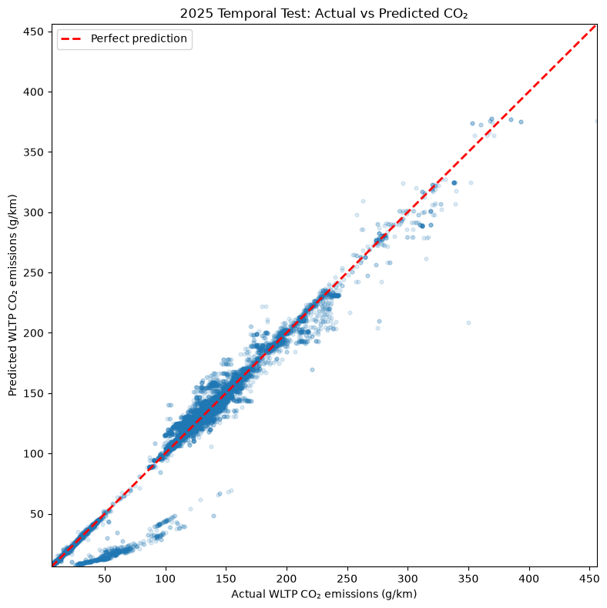

Scatter plot compares the actual and predicted WLTP CO2 emissions for the 2025 temporal test set. The red dashed line represents perfect predictions, where the predicted value is equal to the actual value.
Most observations are located close to the perfect-prediction line, indicating a strong overall agreement between the predicted and observed emissions. The model performs particularly well across the central portion of the target distribution and follows the general upward trend across increasing CO2 values.
However, the plot also reveals several structured error patterns. In the low-emission range, approximately 20–100 g/km, a secondary group of predictions is located substantially below the perfect-prediction line. This indicates systematic under-prediction for some low-emission vehicles, potentially due to differences between plug-in hybrid and conventional powertrain configurations.
The model also shows some under-prediction for a small number of high-emission vehicles, particularly in the upper tail of the distribution. These errors may be associated with rare high-performance or heavy vehicle configurations that are less represented in the training data.
Overall, the plot confirms that the model captures the main relationship between vehicle specifications and WLTP CO2 emissions. Nevertheless, the remaining structured errors show that overall performance metrics should be complemented with seen-versus-unseen configuration analysis and subgroup-level error analysis.

Residual Analysis:
Residuals were defined as: residual=actual CO2−predicted CO2
Therefore, positive residuals indicate underprediction, while negative residuals indicate overprediction.
Residual definition: actual – predicted  Residual min: -46.75555434124311  Residual max: 141.1191181349199  Residual mean: 1.1253470707936255  Residual median: -0.13240116693857829 | Largest positive residual:  Actual: 350.0  Predicted: 208.8808818650801  Residual: 141.1191181349199  Largest negative residual:  Actual: 263.0  Predicted: 309.7555543412431  Residual: -46.75555434124311

The residual distribution showed limited overall bias:
- Mean residual: +1.13 g/km
- Median residual: -0.13 g/km
- Minimum residual: -46.76 g/km
- Maximum residual: +141.12 g/km
The median residual was close to zero, indicating that the model was broadly well calibrated for a typical 2025 record. The slightly positive mean residual was caused by a small number of large underpredictions.
The largest under-prediction occurred for a vehicle with an actual WLTP CO2 value of 350.0 g/km. The model predicted 208.88 g/km, resulting in a residual of +141.12 g/km. The largest overprediction occurred for a vehicle with an actual CO2 value of 263.0 g/km and a prediction of 309.76 g/km, corresponding to a residual of -46.76 g/km.
The residual-versus-actual plot showed that errors were generally concentrated around zero in the central emission range. However, residual spread increased for low-emission and high-emission vehicles. This pattern suggests that the model captures the dominant relationships between vehicle specifications and CO2 emissions, while rare vehicle configurations and unobserved design factors remain difficult to predict.
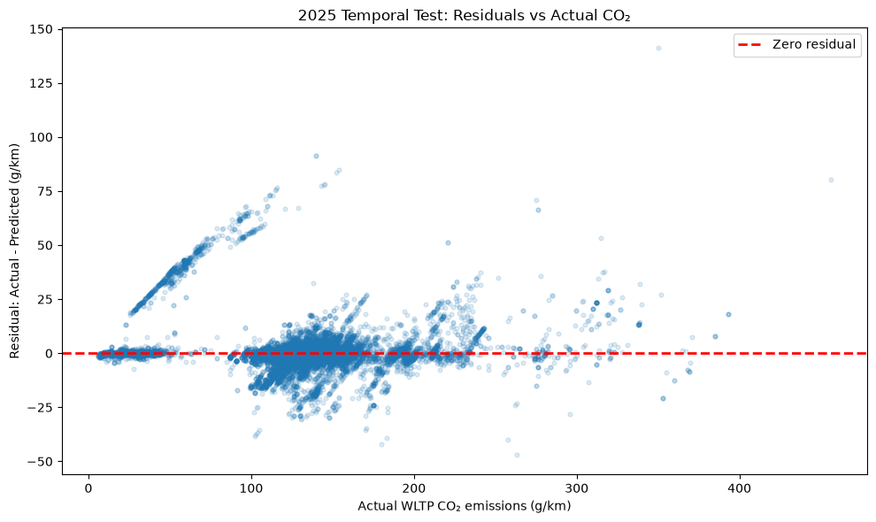
Error Analysis by Fuel Type and Fuel Mode
Fuel type | Fuel mode | Records | Actual mean (g/km) | Predicted mean (g/km) | Mean residual (g/km) | MAE (g/km) | RMSE (g/km)
petrol/electric | P | 2,466 | 36.58 | 27.29 | +9.29 | 9.83 | 20.93
diesel/electric | P | 229 | 22.67 | 13.63 | +9.04 | 9.35 | 18.05
diesel | H | 1,276 | 147.29 | 150.12 | -2.83 | 6.38 | 9.74
petrol | H | 3,907 | 130.63 | 131.63 | -1.00 | 4.16 | 6.35
diesel | M | 3,121 | 157.19 | 157.27 | -0.08 | 3.85 | 6.24
petrol | M | 3,736 | 147.82 | 147.99 | -0.17 | 3.06 | 5.00

Although the model captured that this vehicle had a large engine and very high power, it substantially under-predicted its emissions. This suggests that the model can overgeneralize the low-emission signal associated with PHEV vehicles, especially for rare, high-performance PHEV configurations with short electric range.
A similar pattern appeared for a high-performance PHEV with a 66 km electric range: the actual CO2 value was 140 g/km, while the model predicted 48.47 g/km. This confirms that electric range alone is insufficient to represent the full WLTP CO2 behavior of high-performance PHEV vehicles.
Several heavy petrol/electric PHEV records also had large underpredictions of approximately 77–85 g/km. These records were labelled as seen core configurations because their mass, engine capacity, engine power, fuel type, and fuel mode were present in the 2024 data. However, a seen core configuration does not guarantee an identical full vehicle specification, because additional characteristics such as battery configuration, drivetrain architecture, vehicle version, aerodynamic properties, and WLTP homologation details were not included in the final model.
The analysis also identified a large underprediction for an unseen high-emission petrol configuration. Its actual CO2 value was 456 g/km, compared with a prediction of 375.81 g/km. This result indicates that rare, extreme high-emission vehicles are more difficult to predict because comparable observations are less common in the training data.
The repeated records with similar technical specifications should be interpreted as multiple records with related specifications rather than as 20 completely independent vehicle cases. Overall, the largest errors were concentrated in rare high-performance PHEV vehicles and extreme high-emission conventional vehicles, which likely require additional information not available in the leakage-free feature set.
Distribution of Absolute Prediction Errors
Overall regression metrics such as MAE and RMSE summarize model performance with a single value, but they do not show how errors are distributed across individual records.
To better understand the practical accuracy of the final model, the distribution of absolute prediction errors was analyzed on the held-out 2025 temporal test set.
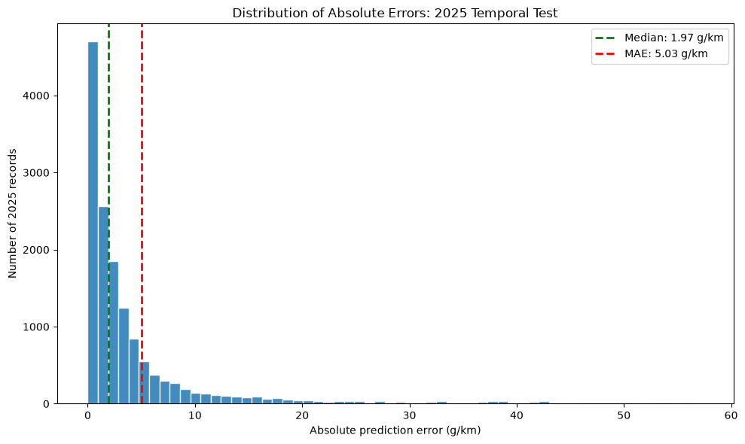
Records with absolute error ≤ 5 g/km: 76.89%
Records with absolute error ≤ 10 g/km: 87.93%
Records with absolute error ≤ 20 g/km: 94.27%
Percentile | Absolute error (g/km)
50th percentile (Median) | 1.9700
75th percentile | 4.6000
90th percentile | 12.2200
95th percentile | 22.8700
99th percentile | 48.9100
Maximum | 141.1200

Error Analysis for Seen/Unseen Vs. Fuel Type/Fuel Mode
The final 2025 test results were analyzed jointly by configuration novelty and powertrain segment.
A record was labelled as **seen** when its core technical configuration; defined by vehicle mass, engine capacity, engine power, fuel type, and fuel mode; had already occurred in the combined 2024 training data. Otherwise, it was labelled as **unseen**.
Configuration status | Fuel type | Fuel mode | records | Actual mean | Predicted mean | Mean residual | mae | rmse | Median absolute error | Pct error over 20
unseen | petrol/electric | P | 404 | 44.8005 | 19.7275 | 25.0731 | 25.5461 | 33.5587 | 31.3815 | 59.9010
unseen | diesel/electric | P | 22 | 37.9365 | 17.0100 | 20.9265 | 21.1726 | 30.7355 | 2.2297 | 45.4545
seen | petrol/electric | P | 2,062 | 34.9670 | 28.7708 | 6.1962 | 6.7481 | 17.4150 | 0.4204 | 14.2095
seen | diesel/electric | P | 207 | 21.0521 | 13.2730 | 7.7791 | 8.0978 | 16.1256 | 0.3335 | 23.6715
unseen | diesel | H | 240 | 146.5259 | 150.8798 | -4.3540 | 12.6889 | 15.5007 | 12.2451 | 25.4167
unseen | diesel | M | 496 | 175.8559 | 175.4246 | 0.4313 | 8.2570 | 11.7162 | 4.4938 | 11.2903
unseen | petrol | M | 424 | 164.8132 | 163.4730 | 1.3402 | 5.8056 | 9.6622 | 3.3216 | 6.3679
unseen | petrol | H | 812 | 136.8319 | 138.6709 | -1.8390 | 7.3638 | 9.6365 | 6.5544 | 2.7094
seen | diesel | H | 1,036 | 147.4675 | 149.9493 | -2.4818 | 4.9135 | 7.8278 | 2.6753 | 4.5367
seen | petrol | H | 3,095 | 129.0048 | 129.7805 | -0.7757 | 3.3165 | 5.1481 | 1.9260 | 0.3877

Key Findings: Unseen Petrol/Electric PHEVs Drive Most Large Errors
The joint analysis shows that the high-error tail in the 2025 temporal test set is concentrated overwhelmingly in previously unseen petrol/electric plug-in hybrid (PHEV) configurations.
For unseen petrol/electric vehicles in fuel mode `P`, the model produced a MAE of 25.55 g/km and an RMSE of 33.56 g/km. These vehicles had an average actual CO₂ value of 44.80 g/km, whereas the average prediction was only 19.73 g/km. This corresponds to a mean residual of +25.07 g/km, indicating systematic underprediction.
More than half of these unseen PHEV records (59.90%) had an absolute prediction error above 20 g/km. Their median absolute error was also high at 31.38 g/km, showing that the issue was not caused only by a small number of extreme outliers.
In contrast, seen petrol/electric PHEV configurations had a much lower MAE of 6.75 g/km. However, they still showed a positive mean residual of 6.20 g/km and an RMSE of 17.42 g/km, indicating that PHEVs remain more difficult to predict than conventional petrol and diesel vehicles even when their technical configurations have appeared in the training data.
For conventional petrol and diesel vehicles, prediction performance was substantially more stable. Seen configurations generally achieved MAE values between 2.70 and 4.91 g/km, while unseen conventional configurations achieved MAE values between 5.81 and 12.69 g/km. The largest non-PHEV error occurred for unseen diesel hybrid vehicles, with an MAE of 12.69 g/km and an RMSE of 15.50 g/km.
Therefore, configuration novelty alone does not explain the observed error distribution. The principal challenge is the interaction between configuration novelty and the petrol/electric PHEV segment. New PHEV configurations appear to have CO₂ emission patterns that are not adequately captured by patterns learned from historical data.

7. Scientific conclusions
1. WLTP CO2 emissions are highly predictable from vehicle specifications in this dataset. The strong performance is consistent with the structured physical and regulatory nature of the data, but it does not mean the model has discovered a causal law.
2. Powertrain regime is central. Electric range, fuel type and fuel mode separate low-emission electrified vehicles from predominantly higher-emission combustion vehicles and explain much of the model’s predictive power.
3. Group-aware validation materially improves scientific credibility. It prevents repeated or near-identical technical configurations from appearing on both sides of evaluation.
4. The temporal test is essential. The final score is still excellent in 2025, but configuration overlap means a second benchmark with stricter unseen-model or unseen-family splits would provide a harder test.
5. The deep-learning result confirms that model-family choice should follow both data structure and evaluation design. The tested MLP and ExtraTrees showed different error trade-offs, so any final head-to-head decision should use the same split, preprocessing, and reporting metrics.

8. Business conclusions and recommendations
The model can support early CO2 estimation, quality checks and scenario analysis before official WLTP results are available, if input variables are available at prediction time. An MAE around 5.03 g/km on the reported 2025 test is useful for ranking and estimating vehicles, but it should not be treated as a regulatory replacement without subgroup and uncertainty analysis.
Recommended deployment position: use tuned ExtraTrees as the primary prediction model; retain Random Forest as a benchmark alternative; keep the strict design-stage model for early product decisions; and use the extended model only when electric-range and IT specifications are genuinely known before prediction.
Recommended safeguards: report prediction intervals; monitor error by fuel mode, manufacturer, emissions range and unseen configuration status; prohibit post-test variables such as direct target proxies; retrain as new model years arrive; and keep a transparent feature dictionary so business users understand required inputs.

MODELING PART II:

Analysis On Segmented Datasets

1. Data Preparation and Experimental Design
The starting cleaned files contained 113,868 2024 records and 88,963 2025 records. Records were grouped by pre-test specification identifiers and technical attributes, and numeric measurements were replaced by registration-weighted means. This reduced the datasets to 15,957 unique 2024 records and 14,735 unique 2025 records.
The target was Ewltp (g/km). The 2024 data were split with GroupShuffleSplit using mass, engine capacity, engine power, fuel type and fuel mode as the core group definition. Training and validation groups were disjoint, so validation measured performance on unseen core technical combinations. The 2025 dataset was kept untouched until final evaluation.
A central improvement was replacing a simple random-style benchmark with a group-aware split. Groups were defined from core technical characteristics: mass, engine capacity, engine power, fuel type and fuel mode. The final split had zero exact core-configuration overlap between training and validation. The 2025 set was not used for model selection or tuning.
Preprocessing was fitted on training data only and then applied to validation and test data. It included make target encoding, training-derived frequency maps, IT-code extraction, one-hot fuel encoding and scaling of continuous variables.
The extension notebook separated the data into Mono-fuel (Fm=M), PHEV (Fm=P) and Hybrid (Fm=H). Each subset was independently group-split, encoded and scaled. The fuel-mode column was removed because it was constant within each subset.
The 2024/2025 record counts were Mono 8,444/6,857, PHEV 2,817/2,695 and Hybrid 4,696/5,183. Training/validation counts were Mono 6,816/1,628, PHEV 2,246/571 and Hybrid 3,745/951.
Each final subset model used ExtraTreesRegressor with n_estimators=388, max_depth=50, max_features=0.6702995511817258, min_samples_leaf=2 and min_samples_split=5, then was retrained on combined 2024 training and validation data.

2. Segmented Temporal Evaluation
The 2025 results show that model performance differs strongly by powertrain segment. Mono and Hybrid predictions were generally stable, whereas PHEV predictions were substantially more difficult, especially for unseen configurations.
Fuel Mode: MONO
2025 subset | Records | MAE | RMSE | R²
All 2025 records | 6857 | 3.8459 | 5.9373 | 0.9746
Seen core configurations | 5937 | 3.4254 | 5.1633 | 0.9769
Unseen core configurations | 920 | 6.5589 | 9.5233 | 0.9634
Seen configurations: 5,937 / 6,857 (86.58%) Unseen configurations: 920 / 6,857 (13.42%)

Fuel Mode: PHEV
2025 subset | Records | MAE | RMSE | R²
All 2025 records | 2695 | 9.6732 | 20.4547 | 0.5044
Seen core configurations | 2269 | 6.7831 | 17.1844 | 0.6289
Unseen core configurations | 426 | 25.0665 | 32.7719 | -0.0684
Seen configurations: 2,269 / 2,695 (84.19%) Unseen configurations: 426 / 2,695 (15.81%)
Fuel Mode: HYBRID
2025 subset | Records | MAE | RMSE | R²
All 2025 records | 5183 | 4.9229 | 7.4179 | 0.9430
Seen core configurations | 4131 | 4.0925 | 6.3299 | 0.9541
Unseen core configurations | 1052 | 8.1839 | 10.6659 | 0.9125
Seen configurations: 4,131 / 5,183 (79.70%) Unseen configurations: 1,052 / 5,183 (20.30%)
Seen configurations were core technical configurations present in the corresponding 2024 training data. Coverage was 86.58% for Mono, 84.19% for PHEV and 79.70% for Hybrid. The negative R² for unseen PHEVs indicates poor generalisation to that subset.

3. Interpretation and Feature Importance
Permutation importance was computed on the 2025 test subsets by repeatedly permuting each feature and measuring the RMSE increase. The dominant features differed by segment.
Segment | Most influential features | RMSE increases (g/km)
Mono | Mt, ep (KW), ec (cm3) | 26.3757, 14.6895, 11.7005
PHEV | Electric range, ep (KW), Mt | 10.4589, 1.8985, 0.3319
Hybrid | ep (KW), Mt, ec (cm3) | 14.6276, 10.9463, 7.5671

These are predictive importance measures rather than causal effects. Electric range is strongly associated with PHEV operating and homologation behaviour, but it does not fully describe high-performance PHEVs.

4. Error Analysis
Residual Analysis:
Residuals were defined as actual CO₂ minus predicted CO₂. Positive residuals indicate under-prediction and negative residuals indicate over- prediction. Mono and Hybrid residuals were mostly concentrated around zero, while PHEV residuals showed a wider spread and many large positive values.
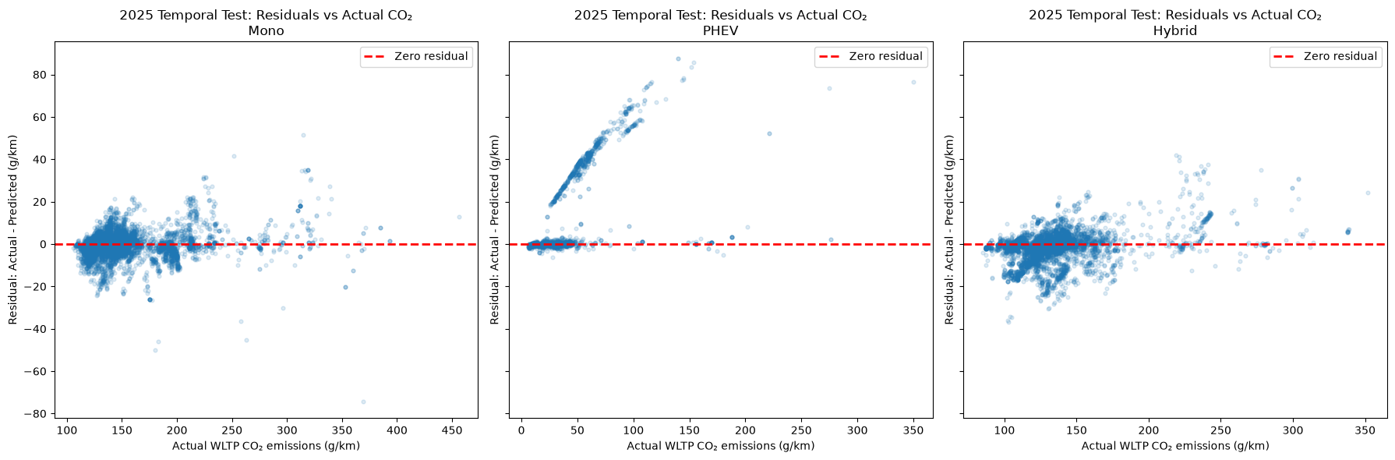
Largest Prediction Errors:
The largest Mono error was 74.16 g/km: actual emissions were 369.0 g/km and the prediction was 443.16 g/km for a seen configuration. The largest PHEV error was 87.44 g/km for an unseen configuration with actual emissions of 140.0 g/km and a prediction of 52.56 g/km. The largest Hybrid error was 41.95 g/km for a seen configuration with actual emissions of 219.0 g/km and a prediction of 177.05 g/km.
PHEV fuel-type analysis confirmed systematic underprediction. Petrol/electric PHEVs had mean actual emissions of 36.5780 g/km, mean predictions of 27.3795 g/km, mean residual +9.1985 g/km and RMSE 20.6618 g/km. Diesel/electric PHEVs had mean residual +9.0703 g/km and RMSE 18.0744 g/km.

Actual vs. predicted CO2 Emissions:
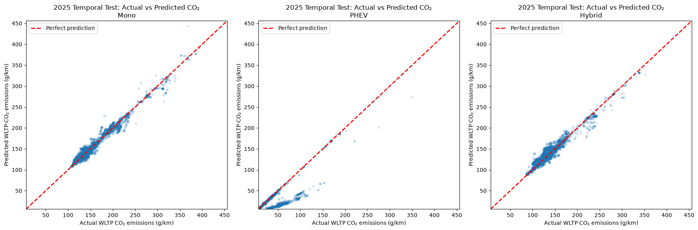
The scatter plot compares the actual and predicted WLTP CO₂ emissions for the 2025 temporal test set. The red dashed line represents perfect predictions, where the predicted value is equal to the actual value.
The Mono and Hybrid models showed strong agreement between actual and predicted WLTP CO₂ emissions, with most observations concentrated close to the perfect-prediction line. Prediction errors increased slightly for high-emission vehicles, where relatively few observations were available.
The PHEV model showed a wider error distribution and a clear tendency to underpredict CO₂ emissions for some vehicles. Several observations with moderate or high actual emissions were predicted substantially below the perfect-prediction line. This result is consistent with the segment-level error analysis, which identified unseen and high-performance petrol/electric PHEV configurations as the main source of large prediction errors.
Distribution of Absolute Prediction Errors:
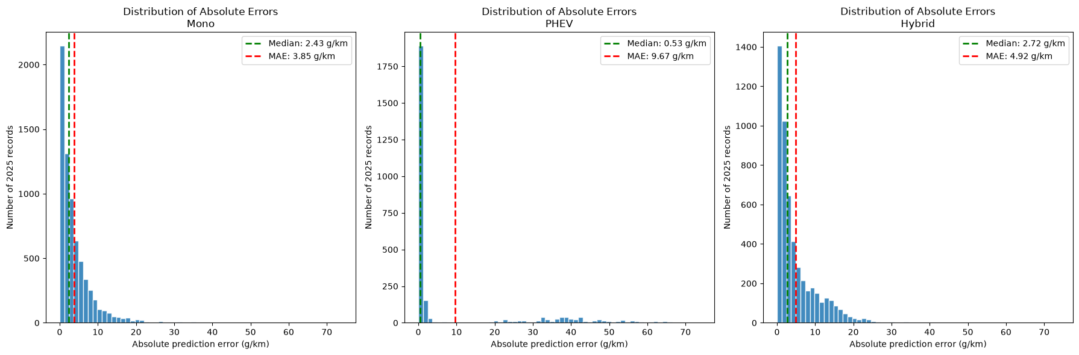
Model | Metric | Value | Unit
Mono | 50th percentile (Median) | 2.4300 | g/km
Mono | 75th percentile | 5.1300 | g/km
Mono | 90th percentile | 8.9400 | g/km
Mono | 95th percentile | 12.4400 | g/km
Mono | 99th percentile | 20.8900 | g/km
Mono | Maximum | 74.1600 | g/km
Mono | Error ≤ 5 g/km | 74.2700 | %
Mono | Error ≤ 10 g/km | 92.2100 | %
Mono | Error ≤ 20 g/km | 98.7200 | %
PHEV | 50th percentile (Median) | 0.5300 | g/km
PHEV | 75th percentile | 2.1200 | g/km
PHEV | 90th percentile | 40.7400 | g/km
PHEV | 95th percentile | 49.4900 | g/km
PHEV | 99th percentile | 65.4000 | g/km
PHEV | Maximum | 87.4400 | g/km
PHEV | Error ≤ 5 g/km | 77.0300 | %
PHEV | Error ≤ 10 g/km | 77.5100 | %
PHEV | Error ≤ 20 g/km | 78.0000 | %
Hybrid | 50th percentile (Median) | 2.7200 | g/km
Hybrid | 75th percentile | 6.7700 | g/km
Hybrid | 90th percentile | 13.0900 | g/km
Hybrid | 95th percentile | 16.2400 | g/km
Hybrid | 99th percentile | 23.8700 | g/km
Hybrid | Maximum | 41.9500 | g/km
Hybrid | Error ≤ 5 g/km | 67.5700 | %
Hybrid | Error ≤ 10 g/km | 83.8300 | %
Hybrid | Error ≤ 20 g/km | 97.7600 | %

8. Final Conclusions and Recommendations
- WLTP emissions are strongly predictable from vehicle specifications, but performance depends on powertrain regime and configuration novelty.
- Use the extended specification set when electric range and IT indicators are available; retain the strict design-stage set for earlier estimates.
- Mono and Hybrid models generalised well, while unseen PHEV configurations remained the principal weakness.
- PHEV errors indicate that battery capacity, drivetrain architecture, vehicle version, aerodynamics and other homologation-relevant variables may be needed.
- ExtraTrees is the recommended primary model. The MLP is a documented complementary benchmark, not the accuracy leader.
- Always report results by configuration novelty, fuel type, fuel mode and error tail rather than relying only on aggregate metrics.
Recommended safeguards include prediction intervals, monitoring by powertrain and novelty status, periodic retraining with new model years, explicit feature-availability documentation and a stricter future benchmark based on unseen vehicle families or manufacturers.

REFERENCES

Project Repository:
https://github.com/DataScientest-Studio/jul26_bds_int_co2

Data Audit Excel Sheet:
EU(EEA) 2024 Data Audit Excel Sheet

Original Data Sources:
EU (EEA) Monitoring of CO2 emissions from passenger cars Regulation (EU) 2019/631

CO2 and pollutant emissions of vehicles marketed in France - data.gouv.fr

